IMPLEMENT PACKET SNIFFING USING RAW SOCKET

EXPT.NO: 6
AIM: To develop a packet sniffer using raw sockets in python that captures and displays the details of Ethernet frame such as source MAC, destination MAC and protocol type.
ALGORITHM:
- Get the local host IP address.
- Create and bind a raw socket.
- Enable IP headers and set promiscuous mode.
- Capture packets using revfrom().
- Extract ethernet frame details (MACs, protocol)
- Display the results continuously.
CODE:
import socket
import struct
import binascii
import textwrap

def main():
# Get host
host = socket.gethostbyname(socket.gethostname())
print('IP: {}'.format(host))

# Create a raw socket and bind it
conn = socket.socket(socket.AF_INET, socket.SOCK_RAW, socket.IPPROTO_IP)
conn.bind((host, 0))

# Include IP headers
conn.setsockopt(socket.IPPROTO_IP, socket.IP_HDRINCL, 1)
# Enable promiscuous mode
conn.ioctl(socket.SIO_RCVALL, socket.RCVALL_ON)

while True:
# Recive data
raw_data, addr = conn.recvfrom(65536)

# Unpack data
dest_mac, src_mac, eth_proto, data = ethernet_frame(raw_data)

print('\nEthernet Frame:')
print("Destination MAC: {}".format(dest_mac))
print("Source MAC: {}".format(src_mac))
print("Protocol: {}".format(eth_proto))

# Unpack ethernet frame
def ethernet_frame(data):
dest_mac, src_mac, proto = struct.unpack('!6s6s2s', data[:14])
return get_mac_addr(dest_mac), get_mac_addr(src_mac), get_protocol(proto), data[14:]

# Return formatted MAC address AA:BB:CC:DD:EE:FF
def get_mac_addr(bytes_addr):
bytes_str = map('{:02x}'.format, bytes_addr)
mac_address = ':'.join(bytes_str).upper()
return mac_address

# Return formatted protocol ABCD
def get_protocol(bytes_proto):
bytes_str = map('{:02x}'.format, bytes_proto)
protocol = ''.join(bytes_str).upper()
return protocol
main()
OUTPUT:

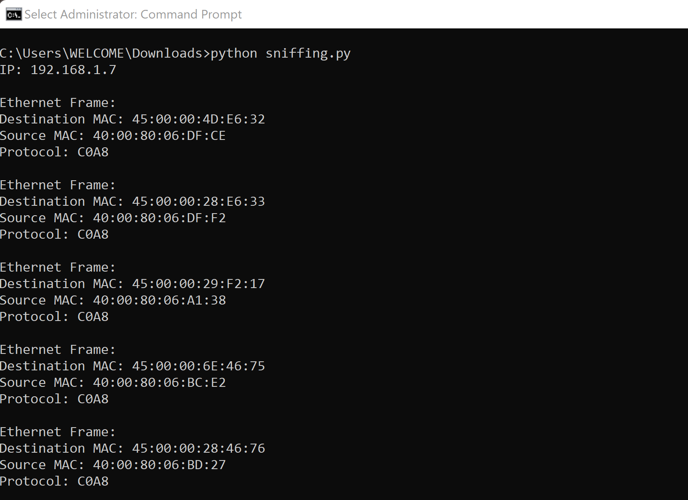

RESULT:
The program successfully captures and delays ethernet frame details of packets flowing through the network interface.

